COURSE CODE & NAME : CSA1712 ARTIFICAL INTELLIGENCE.
Name :Dharshini R D
Reg no: 192521277

Lab exp 01:

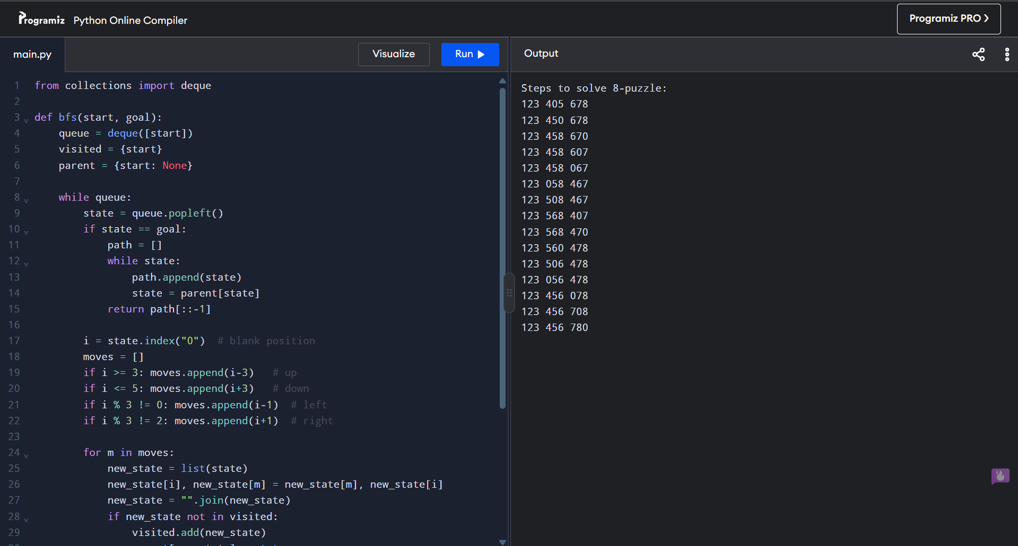

Lab exp 02:

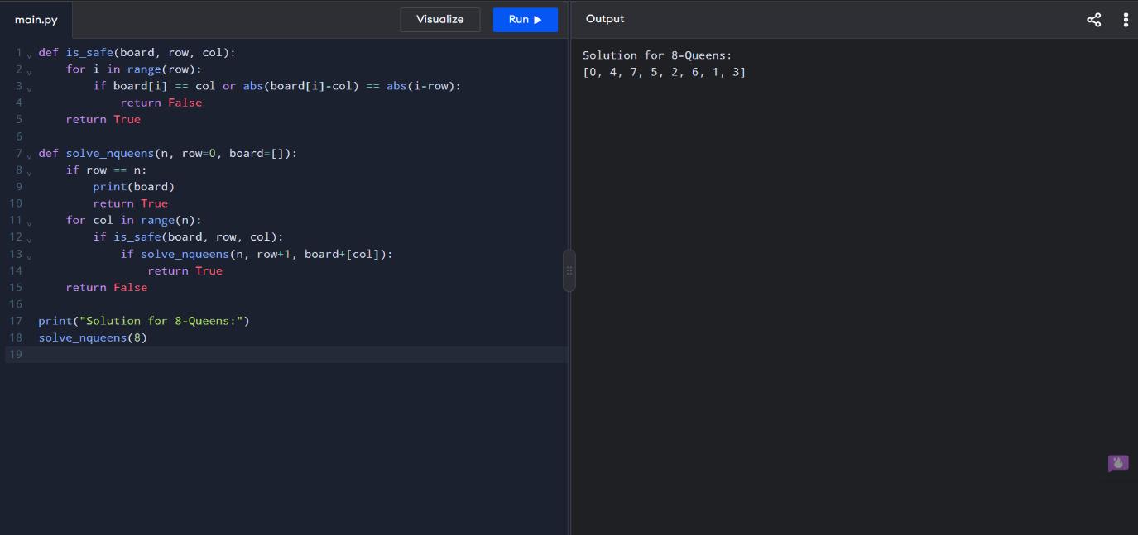
Lab exp 03:

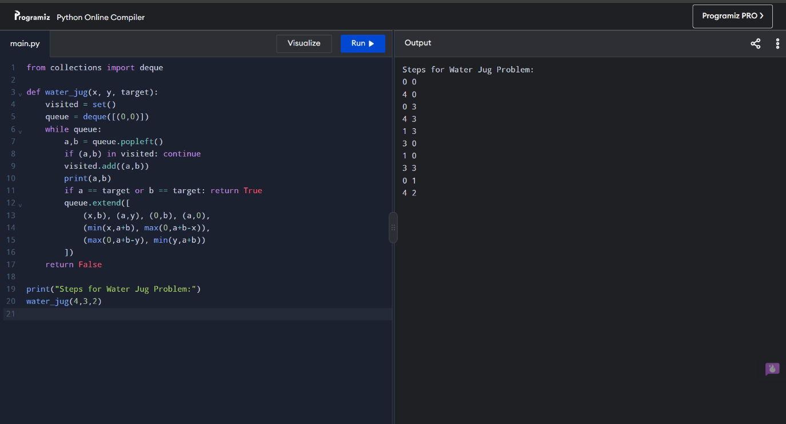

Lab exp 04:

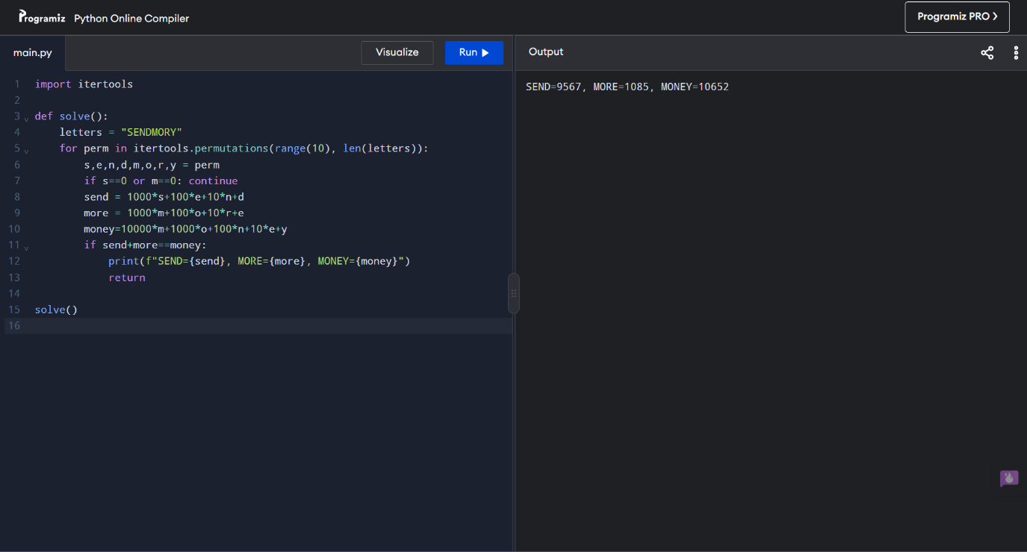
Lab exp 05:

